**ASSIGNMENT -2**

1. **Create registration page in html with username, email and phone number and by using POST method display it in next html page.**

**App.py**

from flask import Flask, render_template,request

app = Flask(__name__)

@app.route('/')

def home():

return render_template('register.html')

@app.route('/confim', methods = ['POST', 'GET'])

def login():

if request.method== 'POST':

u = request.form.get('user')

em = request.form.get('email')

n = request.form.get('no')

return render_template("regsuc.html",name=u,email=em,no=n)

if __name__ == '__main__':

app.run(debug=True)

**register.html**

<html>

<head>

<title>Registration</title>

</head>

<body>

<center>

<fieldset style="width:500px; height:300px; aglin:center;">

<legend>Register</legend>

<form action="/confim" method="post">

<br><br>

<label>User Name</lable>&nbsp;&nbsp;&nbsp;&nbsp;&nbsp;

<input type="text" name="user" >

<br><br><br>

<label>Email</lable>&nbsp;&nbsp;&nbsp;&nbsp;&nbsp;&nbsp;

&nbsp;&nbsp;&nbsp;&nbsp;&nbsp;&nbsp;&nbsp;

<input type="email" name="email" >

<br><br><br>

<label>Phone Number</lable>

<input type="text" name="no" >

<br><br><br>

<p><center><input type="Submit" value="REGISTER"/></center></p>

</form>

</fieldset>

</center>

</body>

</html>

**Regsuc.html**

<html>

<head>

<title>Register success</title>

</head>

<body>

<center>

<h1>Registeration success</h1>

<table border=1 style="width:500px; height:100px;">

<tr>

<td>User Name</td>

<td>{{name}}</td>

</tr>

<tr>

<td>email</td>

<td>{{email}}</td>

</tr>

<tr>

<td>Phone Number</td>

<td>{{no}}</td>

</tr>

</center>

</table>

</body>

</html>

**Output:**

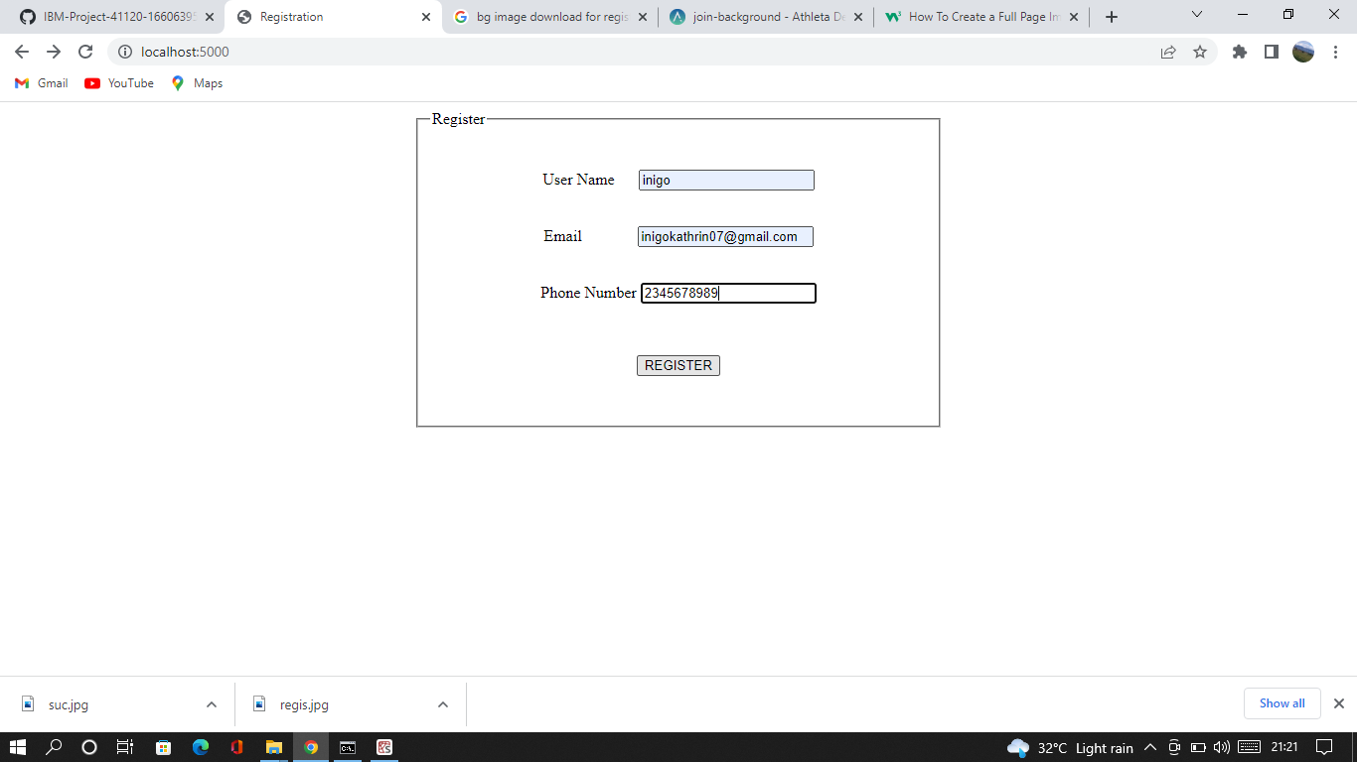

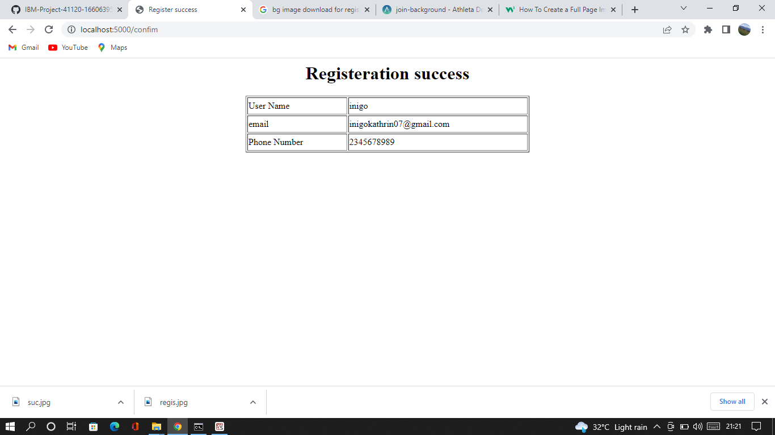

1. **Develop a flask program which should contain atleast 5 package used from pypi.org.**

**Pypi.py**

import camelcase

from jinja2 import Template

import requests

from flask import Flask

import datetime

import numpy as np

**#numpy**

arr = np.array([1, 2, 3, 4, 5])

print(" NUMPY ")

print(arr)

print(type(arr))

print("\n")

**#datetutil**

print(" DATEUTIL ")

now = datetime.date.today()

print(now)

print("\n")

**#requests**

r = requests.get('https://api.spotify.com/')

r.status_code

print(" REQUESTS ")

print(r.headers)

print("\n")

**#jinja2**

template = """hostname {{ hostname }}"""

data = {"hostname": "core-sw-waw-01"}

j2_template = Template(template)

print(" JINJA2 ")

print(j2_template.render(data))

print("\n")

**#camelcase**

c = camelcase.CamelCase()

txt = "lorem ipsum dolor sit amet"

print(" CAMELCASE ")

print(c.hump(txt))

print("\n")

**Output:**

